Where I’m From
DIRECTIONS: Use the template below to draft a poem about where you are from. It can be about your home, neighborhood, town, native country, family, or friends. Be sure to express who you are!

I am from ____________________ and ____________________ (two specific items from your childhood home/hometown)
from ____________________ and _____________________ (two products or objects from your past)
I am from ________________________________( a phrase/appropriate slang describing your childhood home/hometown)
and ____________________________________ (more description of your childhood home/hometown)
I am from ____________________________________________ (a plant, tree or natural item from your past/hometown)
whose _________________________________ (personify—give human qualities to--that natural item)
I am from _______________________________ (two objects from your past)
from __________________ (a family name/last name) and __________________________(another family name last name)
I am from _______________(a family trait or tendency) and _____________(another trait or tendency)
and from __________________________________________ (another family trait, habit or tendency)
from ______________________________________________ (another family trait, habit or tendency)
I am from __________________________________________ (experiences/sports/hobbies)
I am from _______________________ (an ancestor) and ______________________ (another ancestor)
from ______________________ and ________________________ (two foods from your family history)
from ____________________________________________________ (a specific tradition in your family)
and from _______________________ (another tradition/event in your family)
___________________________________________ ( a special memory or an object you had as a child)
I am from those moments ______________________________________________________________
_________________________________________ (conclude by summarizing who you are based off where you come from)

PART II: Copy your poem onto a sheet of paper for your final draft. Be sure to use correct spelling. Follow the capitalization from the template. Include the title and your name.

PART III: Draw a picture next to your poem to symbolize where you are from. YES…you need to color it! The finished product should be colorful and visually pleasing.

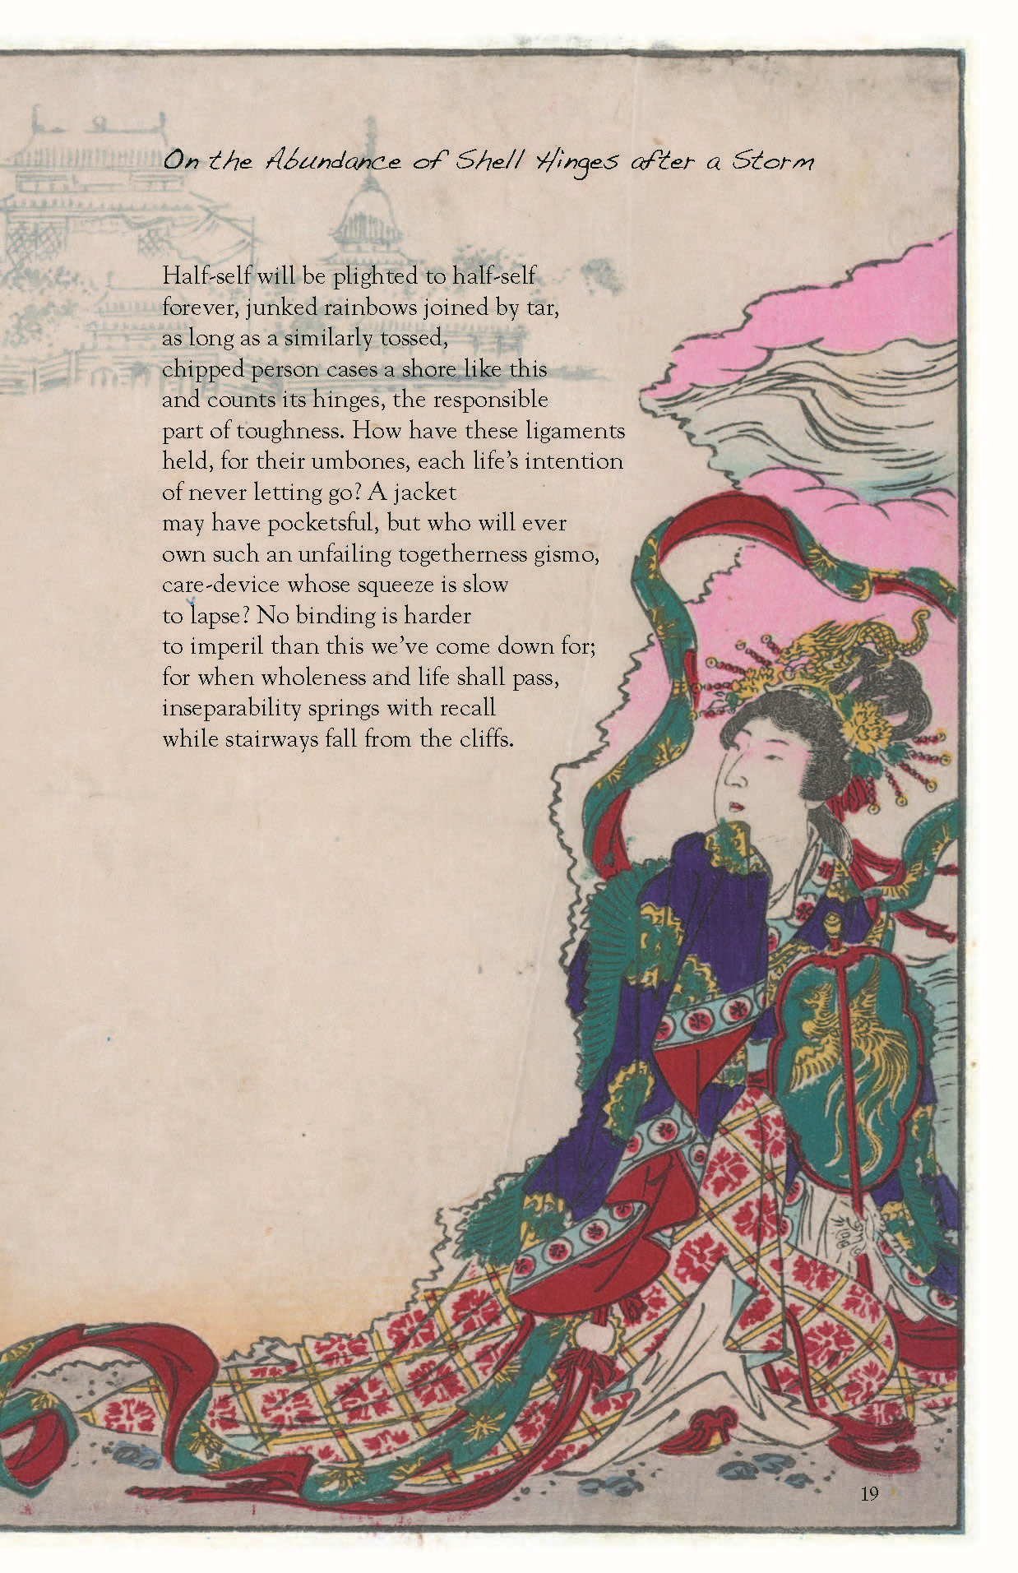
[Example of a decorated poem.]

**This will be your first grade for this class…your best effort is expected and REQUIRED!

GRADING:
- _______ / 10 Template fully completed
- _______ / 10 Final draft completed, with full effort given
- _______ / 10 Picture included, colored
- _______ / 10 Poem presented in group

