Poetry Part 1 Assignments
Directions – Fill out this document digitally (if possible), or answer the questions on a sheet of paper labeling them as best as you can. Submit this to Miss Mueller via remind, email (amy.mueller@cobbk12.org), or Turnitin.com by Friday 4/3 at midnight.
Your Name : TYPE YOUR NAME HERE
Step 1: Review the Poetry PPT notes on the blog. It is advised that you take your own notes as you look through the slides. (Nothing to fill out for this portion).
Step 2: Rhyme Scheme Practice
DIRECTIONS: Identify the rhyme scheme. Use letters A, B, C, D, etc. to designate each new rhyme. Write the letters next to each line as shown in the example provided, or number a sheet of notebook paper #1-36 and label each numbered line with the letter for the rhyme scheme. The first few have been done for you.
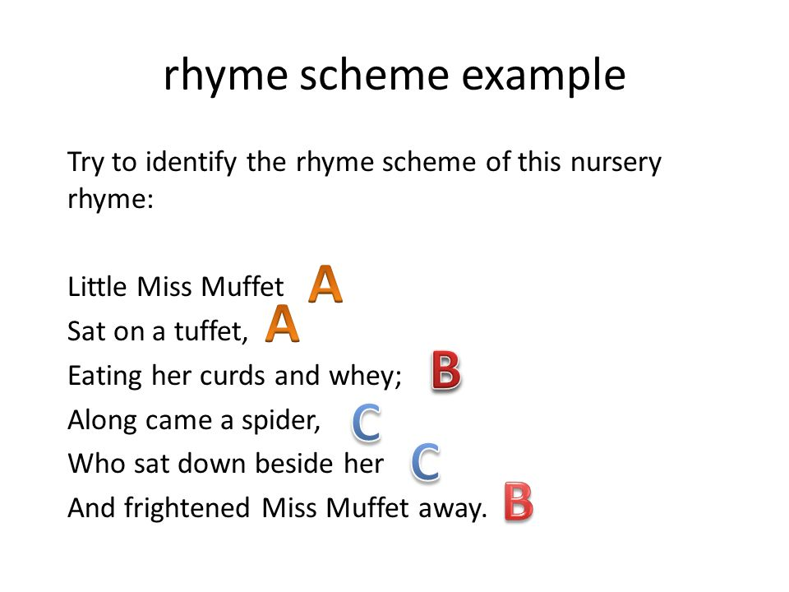
“Lucid Dreams” by JuiceWrld: https://www.youtube.com/watch?v=Mz_4VG-64tE
- I still see your shadows in my room A
- Can't take back the love that I gave you A
- It's to the point where I love and I hate you A
- And I cannot change you so I must replace you (oh) A
- Easier said than done B
- I thought you were the one B
- Listening to my heart instead of my head C
- You found another one, but B
- I am the better one B
- I won't let you forget me D
- I still see your shadows in my room A
- Can't take back the love that I gave you
- It's to the point where I love and I hate you
- And I cannot change you so I must replace you (oh)
- Easier said than done
- I thought you were the one
- Listening to my heart instead of my head
- You found another one, but
- I am the better one
- I won't let you forget me

- I have these lucid dreams where I can't move a thing
- Thinking of you in my head
- You were my everything
- Thoughts of a wedding ring
- Now I'm just better off dead
- I'll do it over again
- I didn't want it to end
- I watch it blow in the wind
- I should've listened to my friends
- Leave this stuff in the past
- But I want it to last
- You were made outta plastic (fake)
- I was tangled up in your drastic ways
- Who knew evil girls had the prettiest face
- You gave me a heart that was full of mistakes
- I gave you my heart and you made heart break
Step 3: Tupac’s “Rose That Grew From Concrete”

DIRECTIONS: Read the poem by Tupac Shakur. Answer the following questions.

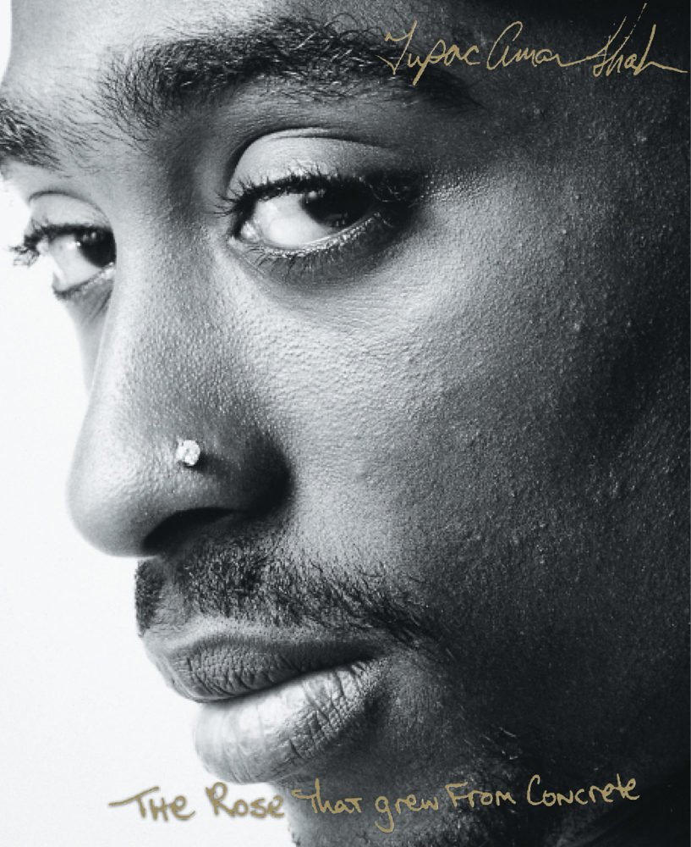

Did you hear about the rose that grew
from a crack in the concrete?
Proving nature's law is wrong it
learned to walk without having feet.
Funny it seems, but by keeping its dreams,
it learned to breathe fresh air.
Long live the rose that grew from concrete
when no one else ever cared.

- How many lines and stanzas are in this poem?
  - Lines =
  - Stanzas =

- Give one example of personification in this poem.

- What is the connotation (emotional association – positive or negative) of a rose? Explain.

- What is the connotation (emotional association – positive or negative) of concrete? Explain.

- What does the rose growing through concrete symbolize?

- Tupac Shakur grew up in a rough neighborhood filled with poverty, crime, and gangs. Given this information about the author. What do you believe is the theme (deeper meaning) of this poem?

Step 4: “Fast Break” by Edward Hirsch
DIRECTIONS: Read and analyze the poem and answer the following questions in the TWIST graphic organizer.

Fast Break
In memory of Dennis Turner, 1946-1984

A hook shot kisses the rim and
hangs there, helplessly, but doesn’t drop,
and for once our gangly starting center
boxes out his man and times his jump
perfectly, gathering the orange leather
from the air like a cherished possession
and spinning around to throw a strike
to the outlet who is already shoveling
an underhand pass toward the other guard
scissoring past a flat-footed defender
who looks stunned and nailed to the floor
in the wrong direction, trying to catch sight
of a high, gliding dribble and a man
letting the play develop in front of him
in slow motion, almost exactly
like a coach’s drawing on the blackboard,
both forwards racing down the court
the way that forwards should, fanning out
and filling the lanes in tandem, moving
together as brothers passing the ball
between them without a dribble, without
a single bounce hitting the hardwood
until the guard finally lunges out
and commits to the wrong man
while the power-forward explodes past them
in a fury, taking the ball into the air
by himself now and laying it gently
against the glass for a lay-up,
but losing his balance in the process,
inexplicably falling, hitting the floor
with a wild, headlong motion
for the game he loved like a country
and swiveling back to see an orange blur
floating perfectly through the net.

TWIST Graphic Organizer
Literary Element | Analysis
Tone: What is the overall tone (attitude) of this poem?
Word Choice: What specific words does the author use to help convey (show) the topic and the attitude?
Imagery: What imagery (a vivid description that appeals to at least one of the five senses) is especially significant for conveying (showing) the attitude of the topic?
Style: How do syntax (sentence and line structure), imagery, and diction (word choice) work together to communicate the main idea of the poem?
Theme: What is the deeper meaning of this poem? Explain

Step 5: “Ego Trippin” By Nikki Giovani
DIRECTIONS: Read and analyze the poem and answer the following questions.
**As you read through this, what continent is the author alluding to throughout this poem?

Ego Trippin’ (There May Be A Reason Why)

I was born in the Congo
I walked to the fertile crescent and built
the sphinx
I designed a pyramid so tough that a star
that only glows every one hundred years falls
into the center giving divine perfect light
I am bad

I sat on the throne
drinking nectar with Allah
I got hot and sent an Ice Age to Europe
to cool my thirst
My oldest daughter is Nefertiti
the tears from my birth pains
created the Nile
I am a beautiful woman

I gazed on the forest and burned
out the Sahara Desert
with a packet of goat's meat
and a change of clothes
I crossed it in two hours
I am a gazelle so swift
so swift you can't catch me

For a birthday present when he was three
I gave my son Hannibal an elephant
He gave me Rome for Mother's Day
My strength flows ever on

My son Noah built new/ark and
I stood proudly at the helm
as we sailed on a soft summer day
I turned myself into myself and was
Jesus
men intone my loving name
All praises All praises
I am the one who would save

I sowed diamonds in my back yard
My bowels deliver uranium
the filings from my fingernails are
semi-precious jewels
On a trip north
I caught a cold and blew
My nose giving oil to the Arab world
I am so hip even my errors are correct
I sailed west to reach east and had to round off
the earth as I went
The hair from my head thinned and gold was laid
across three continents

I am so perfect so divine so ethereal so surreal
I cannot be comprehended
except by my permission
I mean . . . I . . . can fly
like a bird in the sky . . .

Listen to the poem here to get a feeling for the rhythm: https://www.youtube.com/watch?v=nJPOBu8qp6M
Author: Nikki Giovani

“Ego Trippin” Questions:

- Give one example of hyperbole (exaggeration) in this poem.

- What is the effect of hyperbole in this poem?

- What continent is this poem primarily alluding to (referencing)?

- Why do you think the author chose to allude to this continent?

- Give another example of allusion (a reference to something popular in culture) in this poem.

- What is the effect of the allusions in this poem?

- Who is the speaker of this poem and what does she think of herself?

- How does these two images connect to the main idea of this poem?
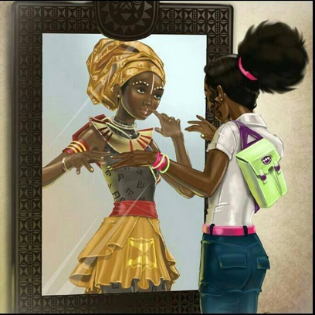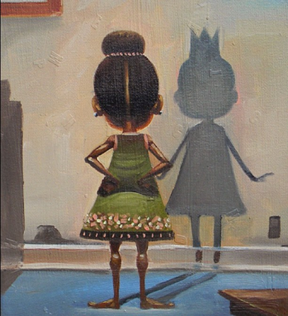

- What is the topic of this poem (literal meaning)?

- What is the theme of this poem (deeper meaning)?

