Name __________________________________________________ Block # _____ Date ____________
“Amigo Brothers”
Short Story Graphic Organizer

- QUICKWRITE: Answer the following question below in complete sentences.

Describe a time you had to compete with one or more friends. Did that experience hurt or help your friendship? Explain.

- LITERARY TERMS:

Theme = a message about ______________ or ________________ nature that the writer wants rea
ders to understand.
Topic = What the story is literally about, or the subject of the story.

EX) The topic of “Amigo Brothers” is friendship. As you read, you will find the deeper message as its theme.

Visual Representation:

Central idea = the most important idea in one section of the text or the overall idea of the whole text. Supporting details = give more information about central idea(s).

- BACKGROUND INFORMATION:
Read A Troubled Beginning and A Rich Heritage. Describe what life was like for the author, Piri Thomas.

- COMPARE AND CONTRAST:
As you read, write the differences and similarities between Felix and Antonio in the Venn diagram below.

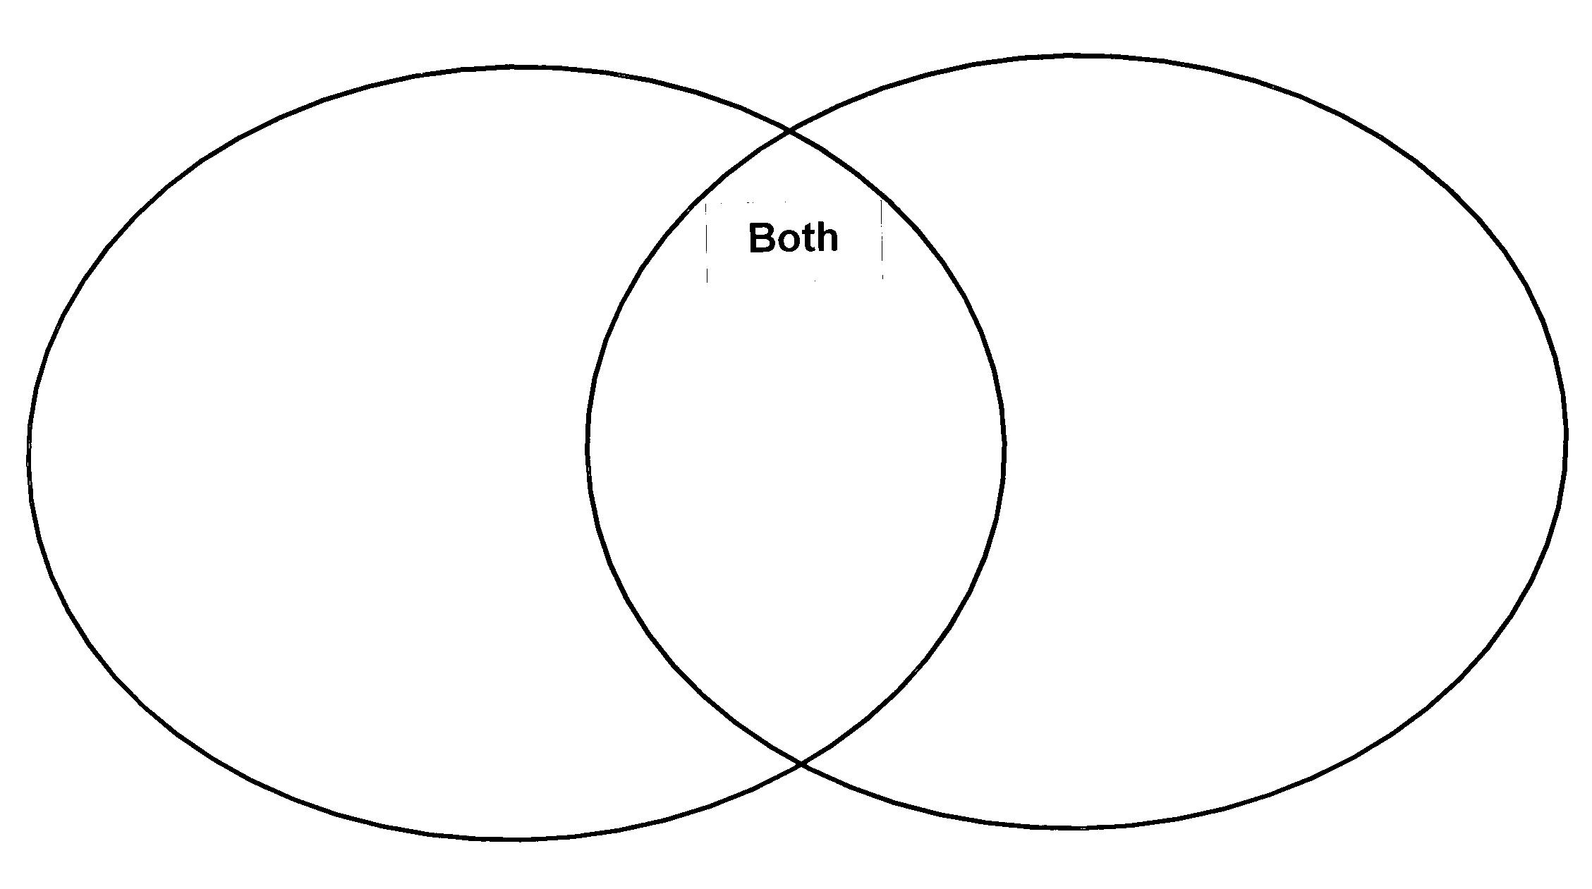
- THEME: What characters say can offer clues about a story’s theme. What does the boys’ dialogue, or conversation tell you about their friendship on page 315?

- Understanding a story’s conflict can help you understand its theme. An internal conflict is a struggle within a character’s mind. Reread lines 102-104. What is Antonio’s inner conflict?

- What can you infer, or guess, about Antonio’s attitude toward Felix on the day of the fight?

- Reread lines 192-195. How do you think the boys feel at this moment?

- THEME: Reread lines 313-317. Why do such good friends keep fighting after the bell rings?

- COMPREHENSION:
- Why was the fight so important to Alex and Antonio?

- What happens at the end of the fight?

- Describe how the two boys fight during the boxing match. What strength does each boy show that they have?

---------------------------------------------------------------------------------------------------------------------------------
PROJECT:
You have two options for your project.

Option 1:
Filmmakers often use music to enhance a movie’s theme. Suppose you were asked to pick three songs for a film version of “The Amigo Brothers.”
- Find three songs that you would select for the “Amigo Brothers” soundtrack.
- Then, write a 1-3 sentence explanation for each song title explaining why you would use this for the soundtrack.
- Present your song selections in small group/partners.

Option 2:
Find out about the early life of a Golden Gloves champion who later became a professional boxer, such as Oscar de la Hoya or Muhammad Ali.
- Conduct internet research to find information on the early life of a former Golden Gloves champion who later became a professional boxer.
- Write 2 paragraphs describing how the person you researched was like Felix and Antonio.
- Present your findings in small group/partners.

