Name __________________________________________________ Block # _____________ Date __________________
“Amigo Brothers” Soundtrack Project
OVERVIEW: You will pick three songs as a soundtrack for the imaginary “Amigo Brothers” movie. You will write three sentences per song explaining how the song connects to the story’s topic, theme, or central idea.

- On the computers OR on your phone, research some possible songs you could use for your soundtrack.
**Your songs MUST be school appropriate!
- Once you have your three songs selected, fill out the portion below:
Song Title | Artist(s)/Band Name | Quote from Song | 2-Sentence reason why it connects to the topic/theme/central idea
1.
2.
3.

Name __________________________________________________ Block # _____________ Date __________________

“Amigo Brothers” Research Project

OVERVIEW: Conduct internet research to learn about a former Golden Gloves champion who later became a professional boxer. Compare how this person was like Felix and Antonio in two paragraphs.

- Search the key words ”former Golden Gloves champions”.
- Click through and read the “early life” bios of a few boxers.
- Find a boxer who has similar life experiences/background as Antonio and Felix
  - EX) Muhammad Ali, Oscar de la Hoya, Mike Tyson, George Forman

- Complete the following diagram before writing your essay (Min. 3 per circle):

Professional Boxer Felix & Antonio
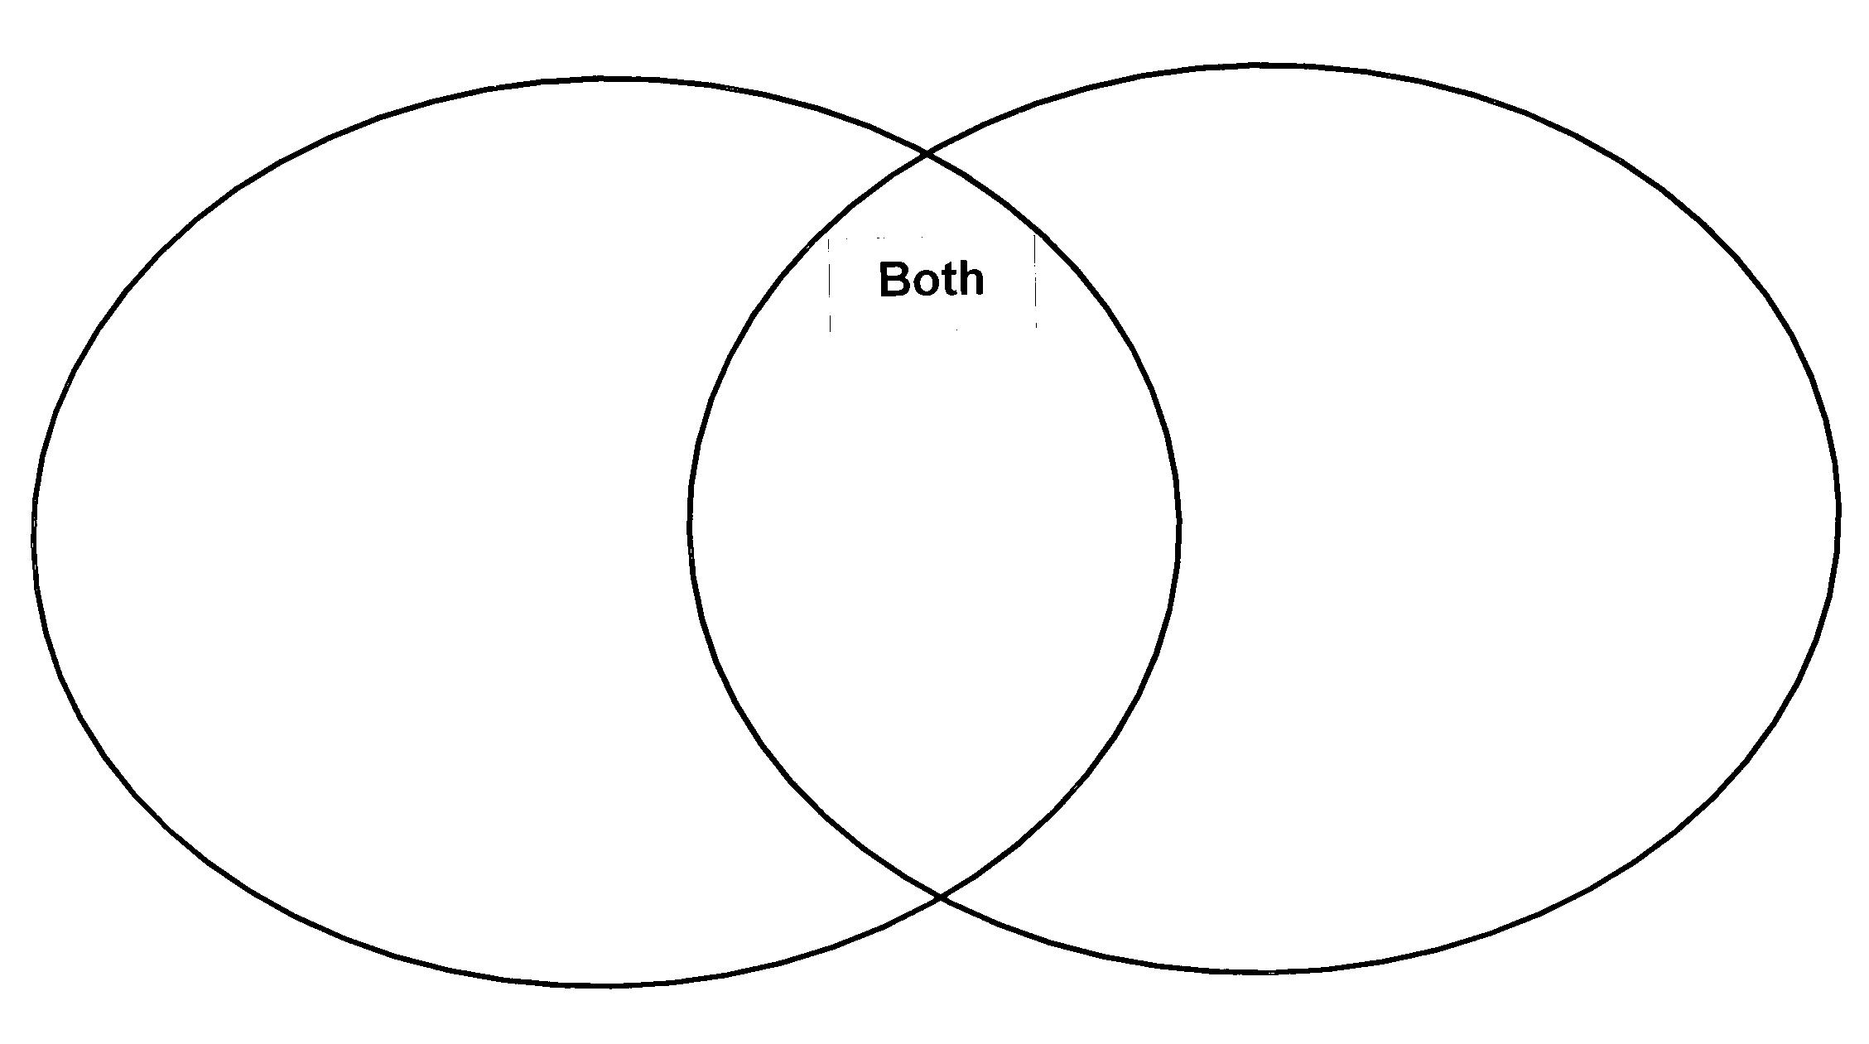
- Introduce your champion boxer in your first paragraph:
  - Name
  - Where they grew up
  - What life was like before boxing
  - Facts about boxing career
- Compare and contrast your professional boxer to Antonio and Felix in your second paragraph.
  - EX) Muhammad Ali grew up like Antonio and Felix because…

Write your essay on a separate sheet of paper and staple it to this paper.

**Both paragraphs MUST be a MINIMUM of THREE COMPLETE SENTENCES long!

